This guide is for our CO.LAB in a Kit: paper circuitry card curriculum, deployed as a ‘mini-CO.LAB’. This workshop is designed to be organized and facilitated by educators or workshop facilitators.

MINI CO.LAB PROGRAM OVERVIEW

CO.LAB is an example of Red Hat’s Open Source Stories, inspiring people everywhere to embrace open source in their own work and communities. Using open hardware and methodologies, we offer a workshop designed to teach students why being open is a better way to work together and a more effective way to solve problems. Our ‘mini-CO.LAB’ is a convenient way to deploy the workshop in a shorter timeframe or within a classroom or camp setting.

Learn more about our stories and activations at redhat.com/opensourcestories.
Details
Curriculum: paper circuitry card
Instructor/facilitator preparation (2 hours total): 1 hour (for cutting materials and kitting); 20 minutes for watching demo; 20 minutes to build a sample card; 20 minutes to explore circuitry background materials
Workshop duration: 2-2.5 hours
Workshop size: 25 students
Space needed: tables and chairs
Materials needed: CO.LAB in a Kit box (here’s a video that shows what’s in your kit), scissors, ball of yarn (optional for collaboration exercise)

PAPER CIRCUITRY CARD OVERVIEW
Students will learn the basics of circuitry, including how electricity moves through a circuit, and how to connect components to bring a project to life. This workshop yields a completed greeting card; all materials (with the exception of scissors) are included in the CO.LAB in a Kit box.

WORKSHOP SCHEDULE

15 MINUTES | INTRODUCTION TO RED HAT, OPEN SOURCE AND COLLABORATION  COLLABORATIVE ICEBREAKER  Materials needed: a ball of yarn for each group
CO.LAB isn’t designed to teach coding; it’s designed to teach the fundamental principle of open source software -- collaboration.

We use a cookie metaphor to explain how open source software is developed and how it is different from proprietary software. If you want to make peanut butter cookies, you need to figure out a lot of things to make a recipe, like how much flour, how much sugar, how long to bake them and at what temperature, etc. But if a friend gives you a basic cookie recipe, you only have to figure out how to add peanut butter to improve it to meet your needs. Similarly, open source software allows everyone to contribute their parts to make the whole better. (You can also download our open source cookie recipe and make your own improvements.)

Open source references:
- What is open source software?
- The open source way (applying the principles of open source development outside of code)
- Open Source Stories

We use a ball of yarn to demonstrate the power of working together. Divide the class into 5 groups and give each group a ball of yarn. Groups should arrange themselves into a circle. Have someone start by holding the ball of yarn and saying his/her name. Then he/she should say the name of someone in their group, and toss the ball of yarn to that person. The person receiving the ball of yarn says the name of someone else in the group, and tosses the ball of yarn to that person. The pattern continues until everyone has had at least one chance to catch and receive the ball of yarn. The instructor/facilitator should monitor the progress, and after a couple of minutes ask the teams to reverse the order. So the person who has the yarn has to remember who they received it from, say his/her name, and toss it back - the goal here is to unwind the tangle of yarn by reversing the order. The lesson is that we all have to work together (to remember where the yarn originated and to help with names) in order to unwind effectively.

5 MINUTES | CURRICULUM OVERVIEW  Today we’ll learn about circuitry, and we’ll build cards that light up when we press a button.
30 MINUTES | TECHNICAL SESSION: INTRODUCTION TO CIRCUITRY  Intro to Circuits  What makes a circuit?
Instructor: You’ll need to tailor the depth of your explanation to your students. A good introduction to circuitry can be found here: https://learn.sparkfun.com/tutorials/what-is-a-circuit. It is appropriate for a middle grades audience.

Topics you may want to cover include:
- Components of a circuit
- How electricity “moves” through a circuit
- Conductivity
- Short circuits
- Open circuits
- Circuit diagrams
- Connecting components in parallel and series

However, if your students are not familiar with electricity or circuits at all, and you would like to simplify your explanation, all they really need to know is that for electricity to power something, the electrons must have a complete circle (circuit!) to follow. Use the guidelines below to introduce them to the basic concept they’ll be demonstrating with their own circuits. You can also use analogies like blood flowing through your body (making a complete loop back to your heart) or cars on a circular track.

What is the circuit we’ll be making? It uses copper tape (which conducts electricity like wire) to connect several LEDs to a small battery.

Instructor: Draw the circuit on the whiteboard as you go through the next section, pointing out the pieces.

In this drawing, you see the battery. We call this a “coin cell” battery. The positive (+) side is on the top (where you’ll see words engraved on it) and the negative (-) side is on the bottom.

There are also two paths of copper tape, one positive and one negative. The positive line of tape must touch the positive side of the battery, and the negative line of tape must touch the negative side of the battery.

But a circuit isn’t complete until it makes a complete circle for the electrons to follow. The LED (represented by a triangle with a green dot in the upper right of the drawing) has a positive side and a negative side as well. It is the last piece to complete the circle.

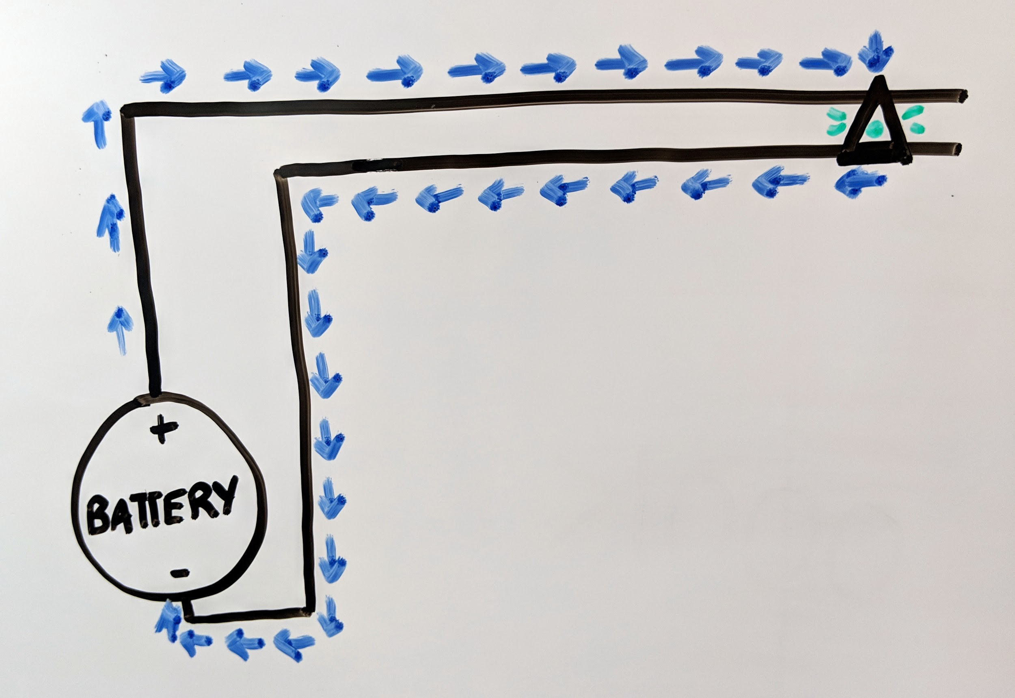

But the circuits we’re going to make today have more than one LED. That’s ok. The electrons follow the positive path, enter each LED, and continue making the loop.

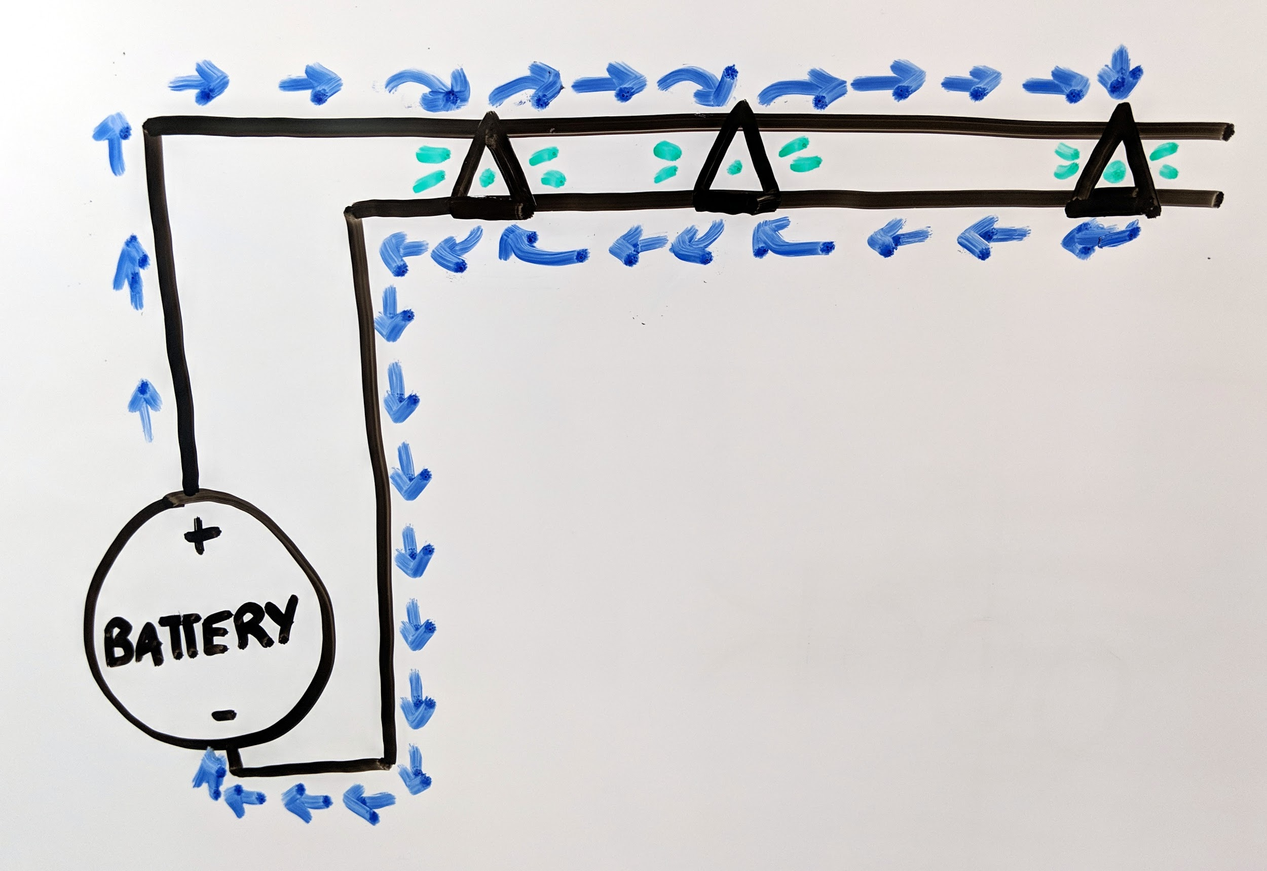
Important things to know about circuits:
- Circuits have two “legs” or traces, one positive and one negative. These two traces cannot touch one another or the circuit won’t work - it will “short out”. In addition, a piece of metal that touches both traces at the same time can cause a short.
- Many types of electrical components (like the LEDs we’ll be using) have “polarity,” which means they have a positive end and a negative end. When you create a circuit, you have to make sure that the positive ends are all connected and the negative ends are all connected. If you put a component in a circuit with the positive end where the negative end should be, the circuit won’t work. It’s kind of like putting your jeans on inside out -- the zipper won’t work.
- Think of a circuit like a stream that water is running through. If there’s a break in the stream, the water won’t flow, and the same thing is true for your circuit: When you make your circuit you have to ensure your components have a good connection -- that your LEDs are stuck down really well, for example.

45 MINUTES | HANDS-ON SESSION: MAKING A CIRCUIT  Instructor suggestion: Create supply “kits” and set up the room in advance.
Create the circuit path
- Using the double-sided tape, adhere the battery flap to the card base where indicated.
- Starting with one strip of the copper tape on the underside of the battery flap, follow the illustration to adhere the positive lead along the positive lead line. *Make sure the copper tape starts under the flap, so it will touch the top of the coin cell battery, and wraps around the top of the flap to follow the positive lead line. Double check the demo and photos on Github to make sure this part is correct.
- Using the second strip of the copper tape, start at the battery and follow the negative lead along the negative line.

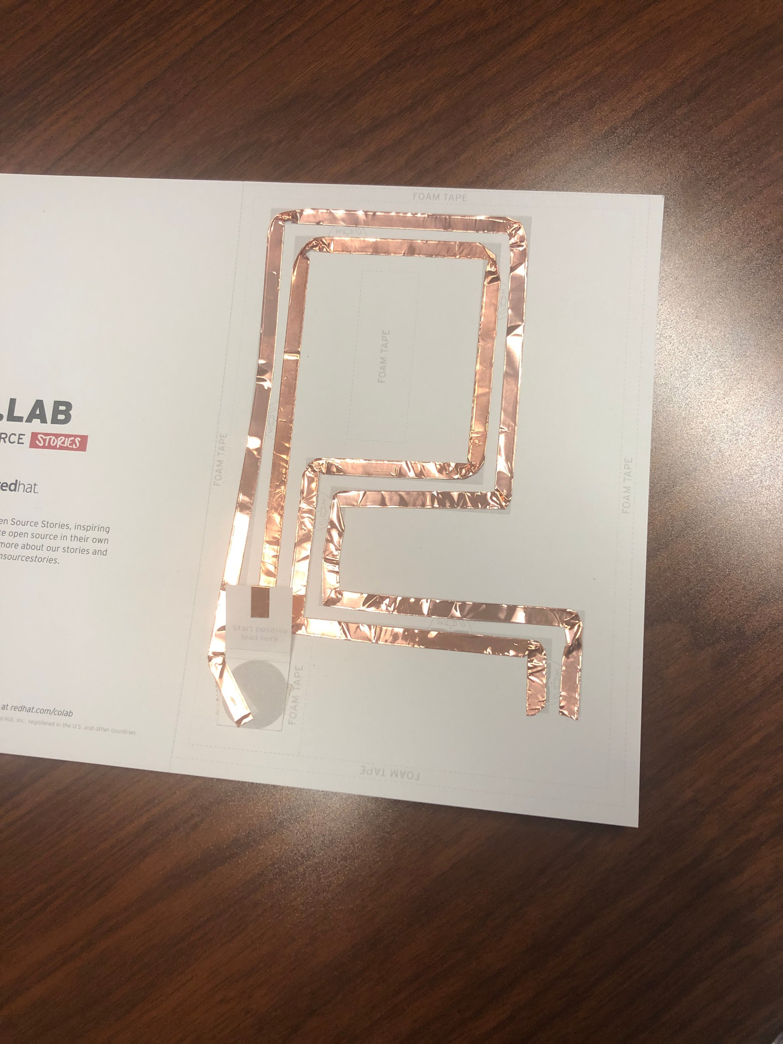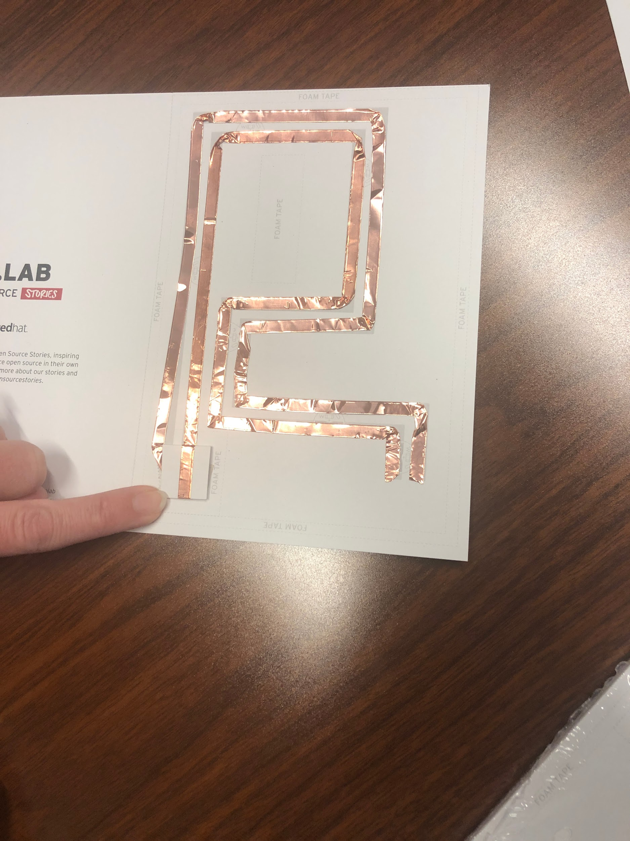

Position the LEDs
- Using the illustration, adhere the LED stickers along the circuit.
- Ensure that the positive and negative sides of the LED’s are aligned with the positive and negative leads.
- Applaud yourself. You just built a circuit.

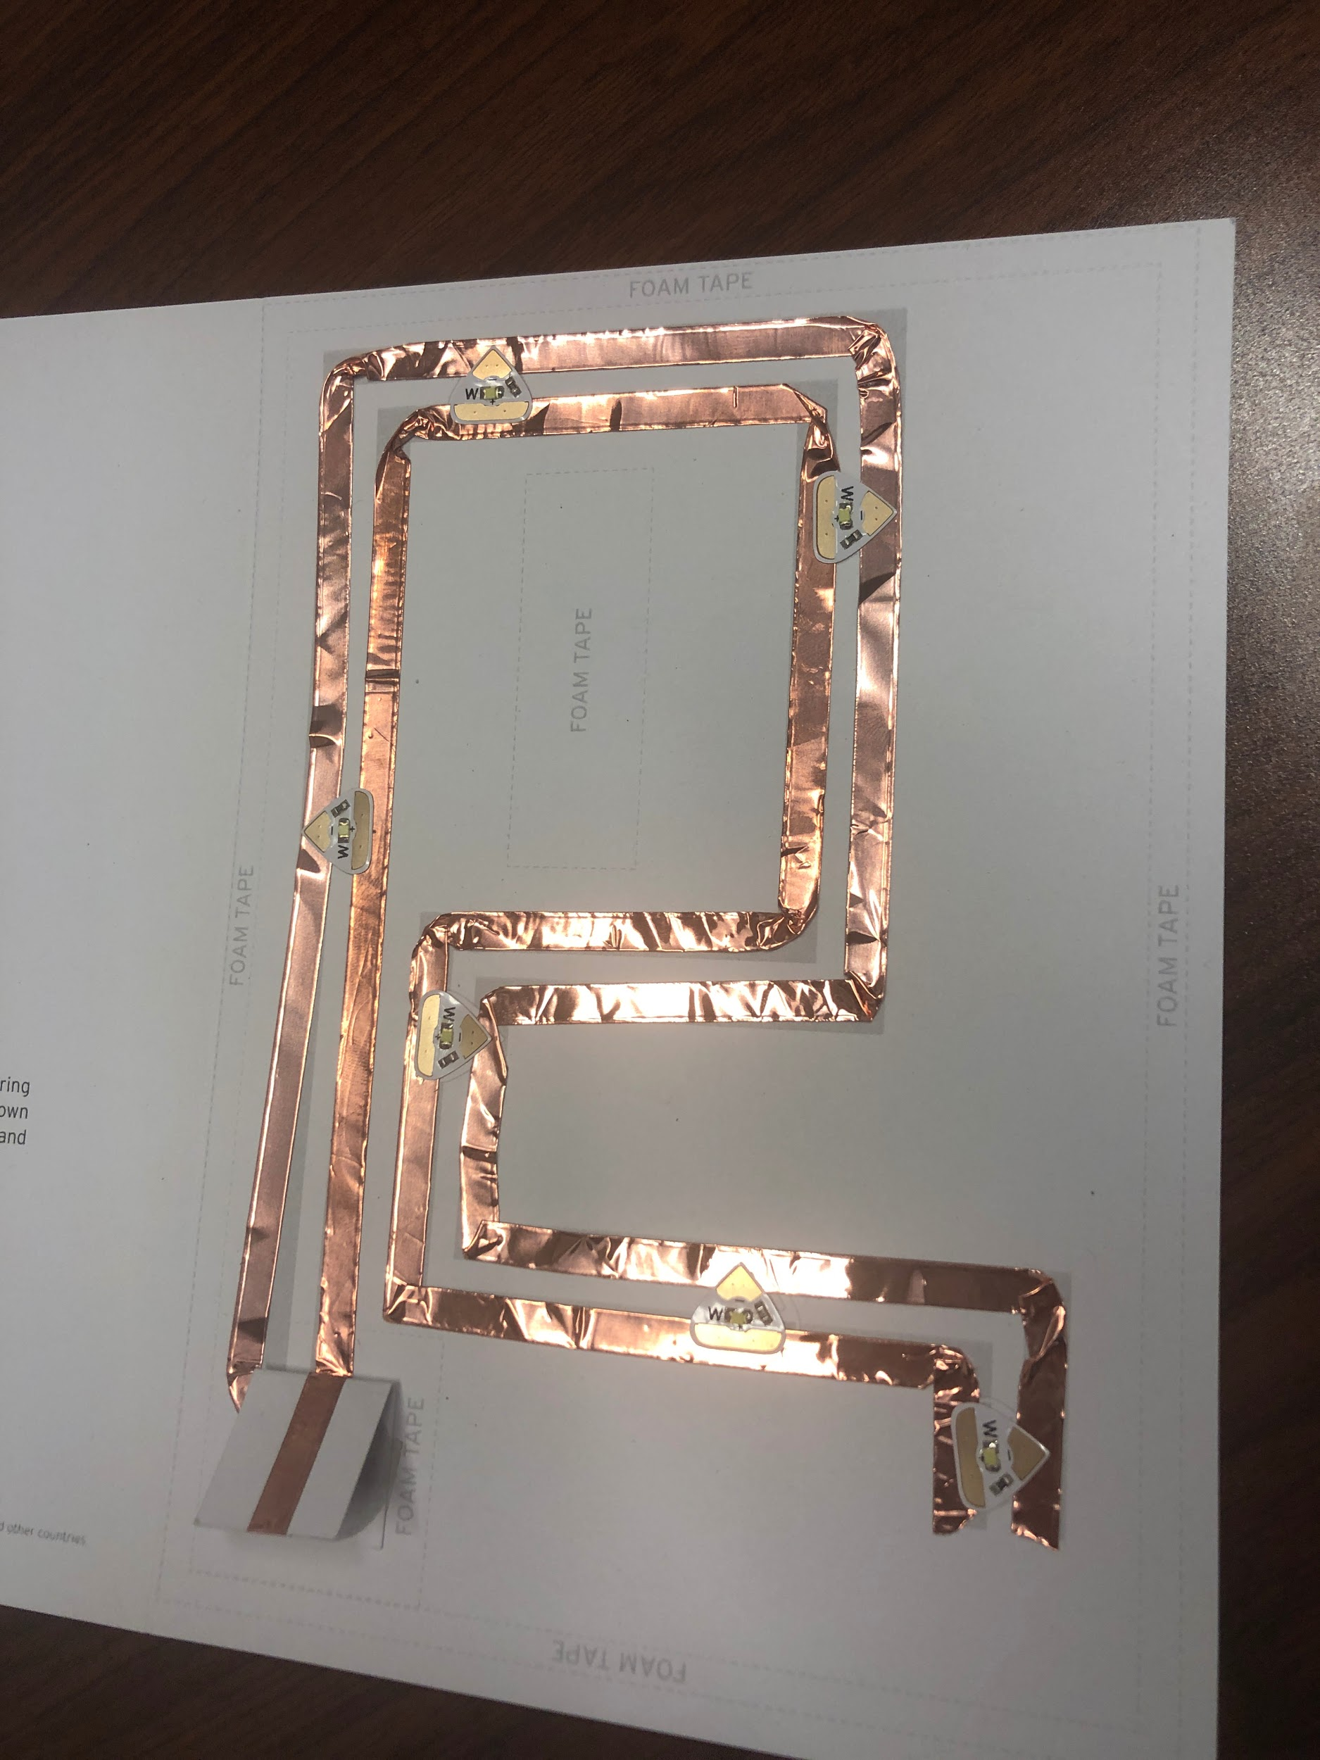
Test your circuit
- Position the negative side of the coin cell battery on the diagram, under the battery flap.
- Press the flap closed, and watch your LEDs light up.
- LEDs not lighting up? Try the troubleshooting steps listed at the end.

Build the support
- Using the .25” wide mounting tape, follow the illustrations to create a border around the edges of the card base. Once the border is created, remove the protective film. Repeat this step to create a second layer of tape stacked directly on top of the first.

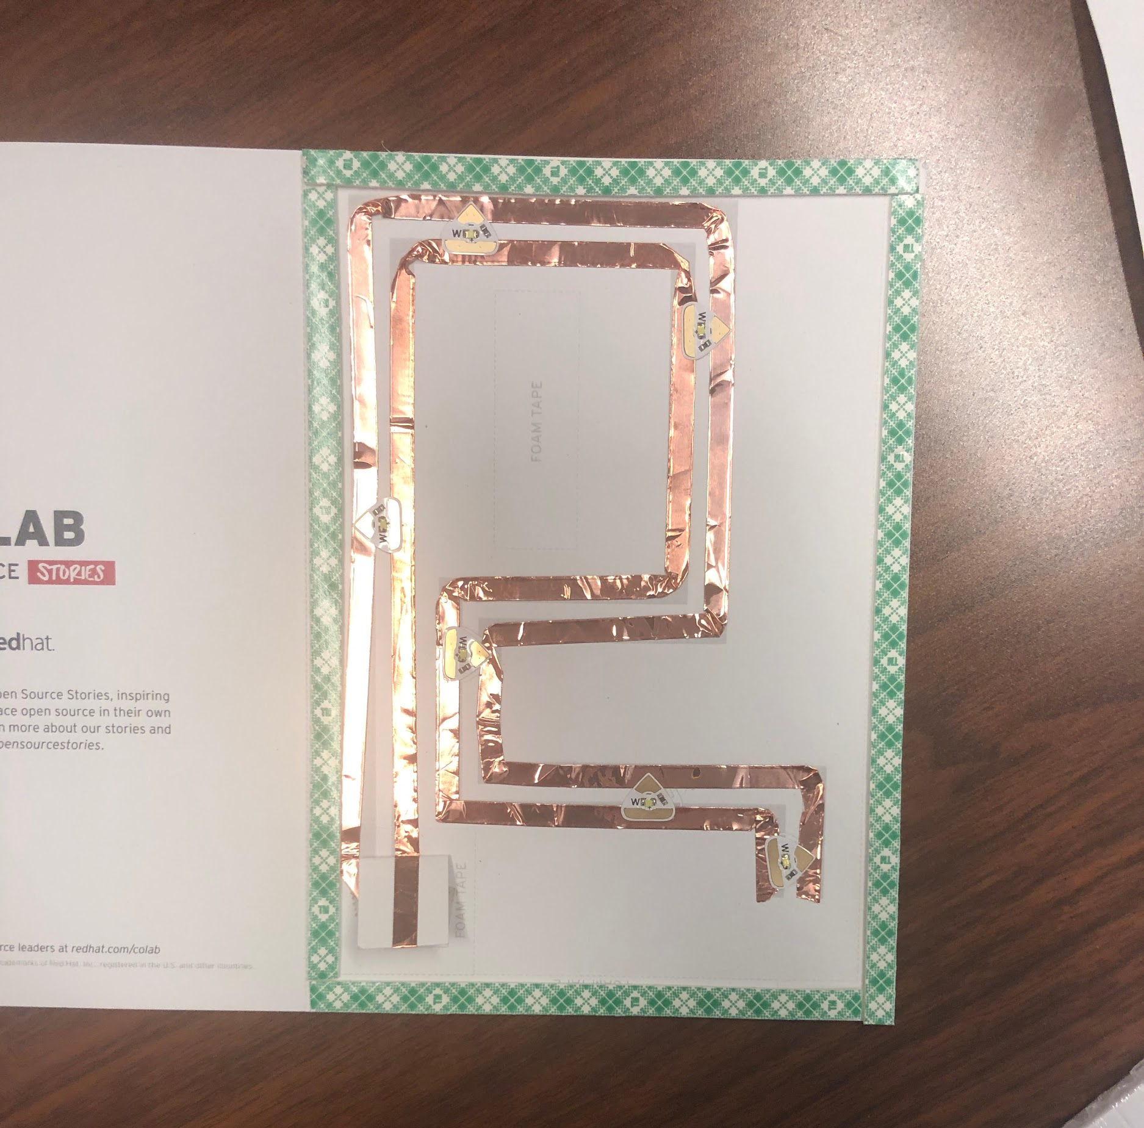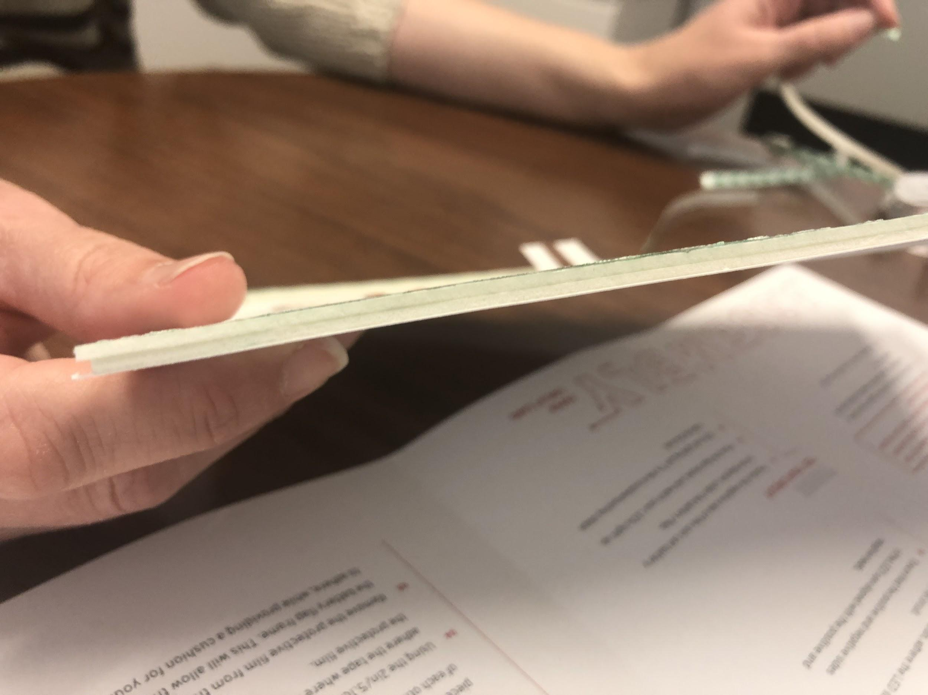

- Using the .25” wide mounting tape, follow the illustrations to make a frame around the battery flap. Once the border is created, remove the protective film. Repeat this step to create a second layer of tape stacked directly on top of the first.
  - Remove the protective film on the top and bottom pieces of the battery flap frame ONLY. Create a third layer of tape on the top and bottom pieces ONLY. You should have three layers stacked on top of each other for the top and bottom only. This extra support ensures that the battery is activated only when you press the button.
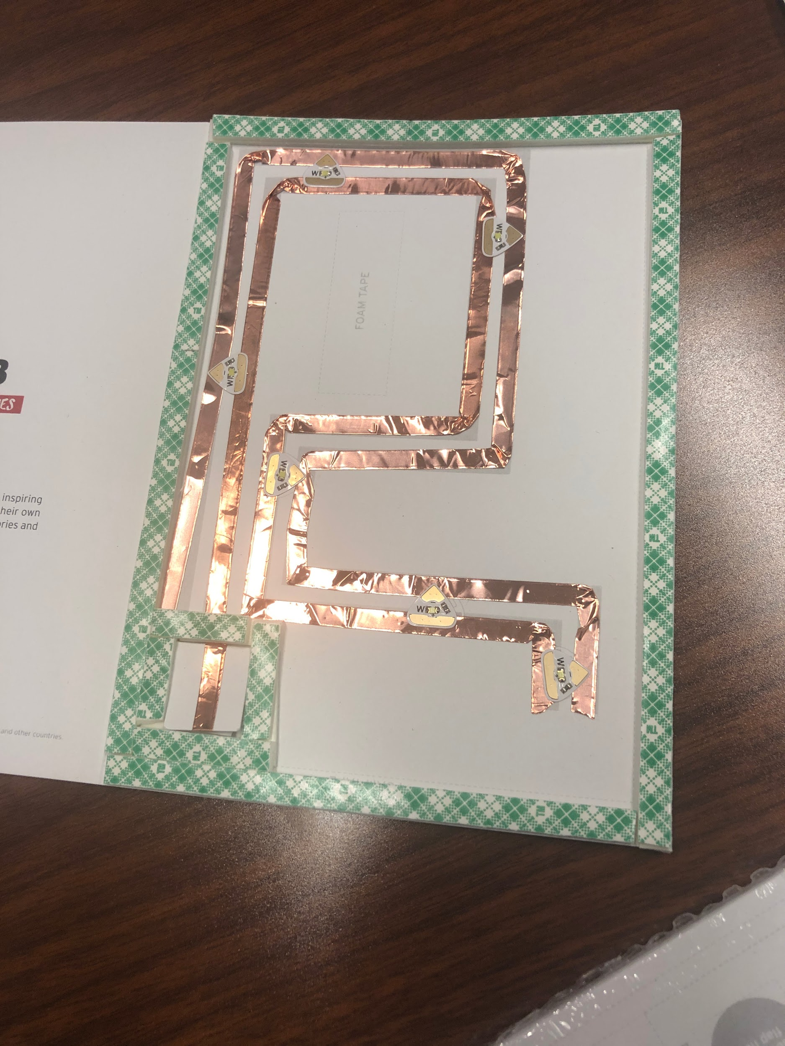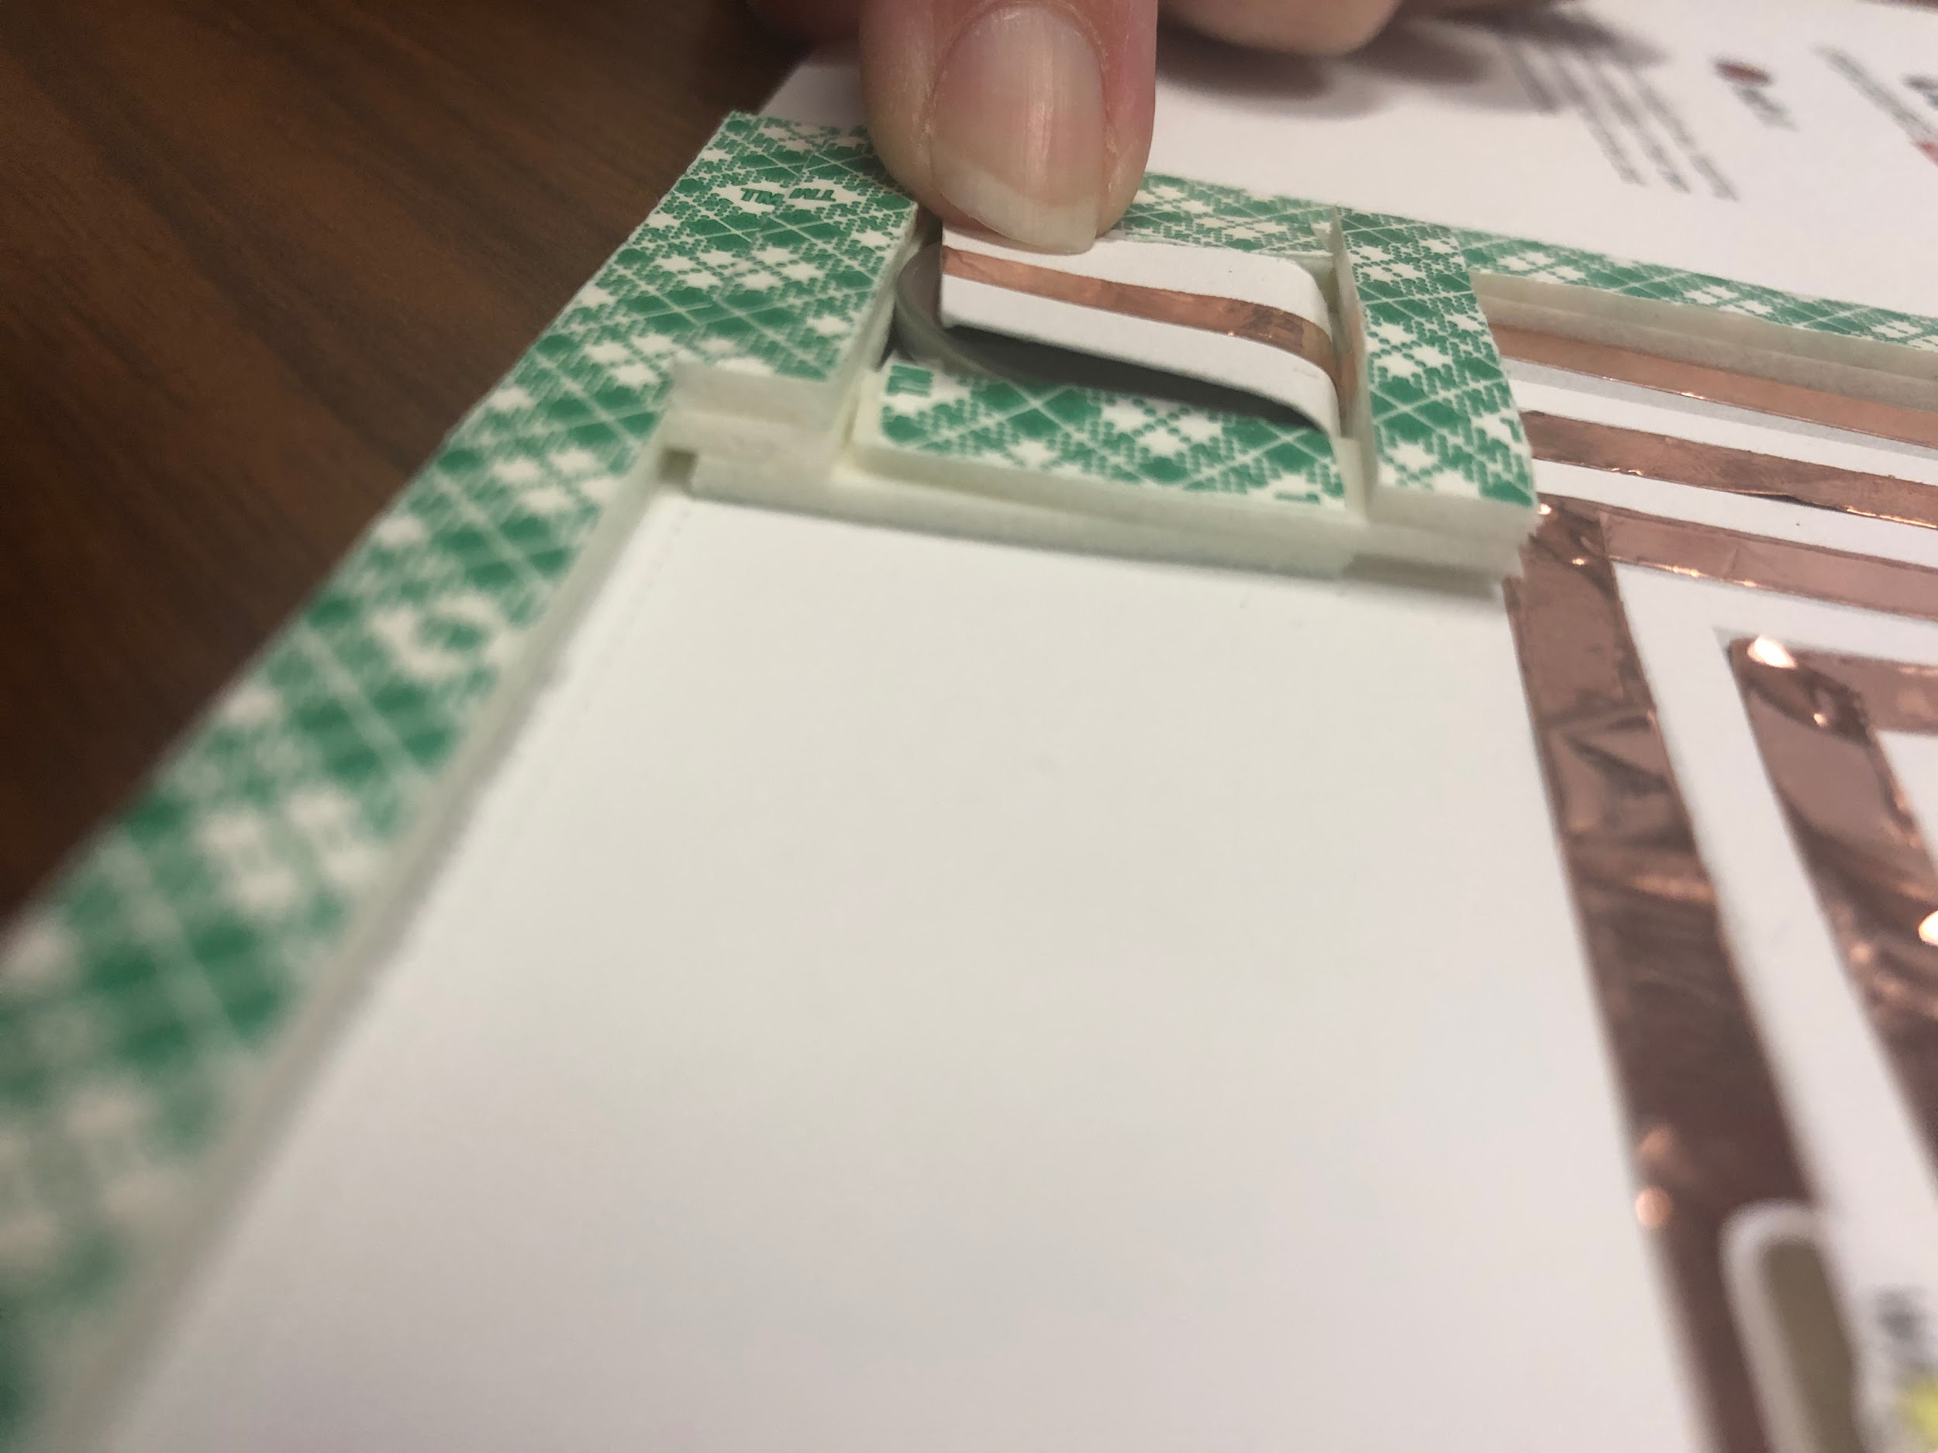

- Using the 2 ” strip of 1” wide mounting tape, adhere the tape where indicated on the illustration. Remove the protective film.
- Remove the protective film from the card border, NOT the battery flap frame. This will allow the overlay sheet to adhere, while providing a cushion for your battery.
- Insert your battery into the battery frame.
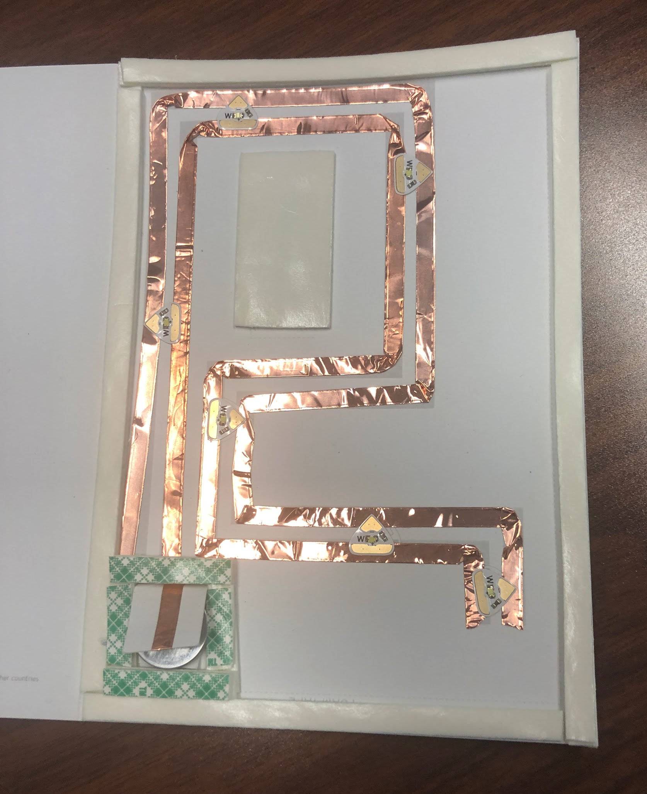

- Double check that your battery and LEDs are still working.
- Choose your design and adhere the overlay sheet to the card base and support system you just built.
- Test again that your LEDs light up.
- Fold the card. The inside is blank for your own message and the back side has the Red Hat CO.LAB logo on it.
- High five your neighbor. You just built an electronic card.

NOTE: if you decide to mail this card, please check your local postal regulations. There may be restrictions on weight and the lithium battery inside your card.
15 MINUTES | WRAP UP
- Have an open discussion with the students about:
  - What they learned (e.g., what is open source? What is collaboration?)
  - What was easy and what was difficult.
  - How they applied the principles of open source during the project.
- Brainstorm on what could be done differently within the workshop.
- Send your feedback and ideas to colab@redhat.com
- Please complete this Google form to provide feedback on the workshop.
- We’d love to see images/video from your workshop via social media. If you post, please tag us using #redhatcolab

